Learn about Creative Commons
Lesson Plan about how to license your work so that it can be easily and legally shared.
Don Watkins

OVERVIEW & PURPOSE
The Student will learn about copyright and how to use Creative Commons licensing.

EDUCATION STANDARDS
- ISTE Learning Standard -2b - Students engage in positive, safe, legal and ethical behavior when using technology, including social interactions online or when using networked devices.

OBJECTIVES
- What is copyright?
  - “Creative Commons (CC) has enabled a new approach to copyright licensing. CC licenses facilitate novel social, educational, technological, and business practices, and support productive relationships around networked knowledge and culture.”
- Students will learn how to identify images and other resources that may be modified and shared legally.
- Students will learn how to decide and apply Creative Commons Licensing for their own work.

MATERIALS NEEDED
- Linux Laptop
- Access to the Internet
- Creative Commons Image Search

Instructions
- Watch the video about Creative Commons licenses and learn how you can decide how to license your own work.
  - Use the CC Search to find an image that you would like to view like a teddy bear. Be sure to select the appropriate checkboxes below deciding whether this image will be used for commercial purposes and/or modify or adapted.
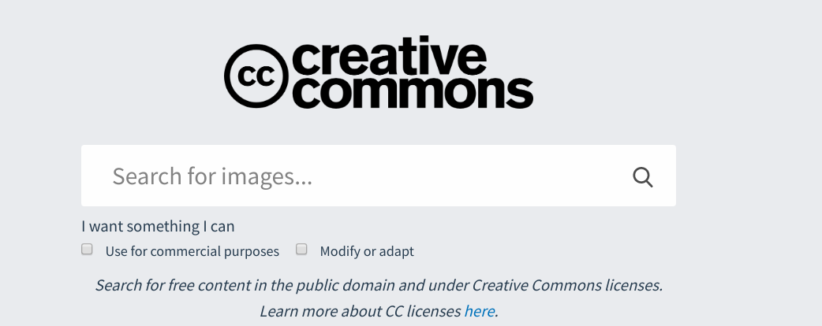
- Modify the image your created using a video editor like Gimp or an online photo editor like Pixlr. If you downloaded an image that was licensed CC by or CC by SA then you will need to license your work accordingly and credit the original author in your attribution.
- Refer to the Creative Commons “Choose a License” for additional assistance and guidance.

Further Study
Further study : https://creativecommons.org/about/

This work is licensed under a Creative Commons Attribution 4.0 International License.

